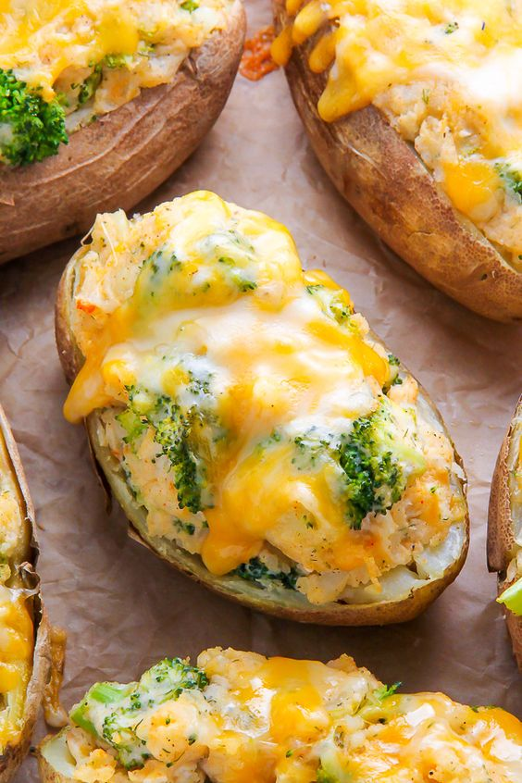
Gevulden gebakken aardappels

Ingrediënten
Groenten
• 1 1/2 cups Broccoli, cooked
• 3/4 tsp Chives
• 1/2 tsp Dill weed, dried
• 3/4 tsp Garlic powder
• 1/2 tsp Onion flakes, dried
• 1/2 tsp Onion powder
• 4 Russet potatoes, medium
Bakken en specerijen
• 1/2 tsp Paprika
• 1/2 tsp Pepper
• 1/2 tsp Salt
Olie en azijn
• 1 tsp Olive oil
Zuivel
• 3 1/2 tbsp Butter, salted very soft
• 1/4 cup Buttermilk
• 2 cups Cheddar cheese
• 1/2 cup Greek yogurt, non-fat

